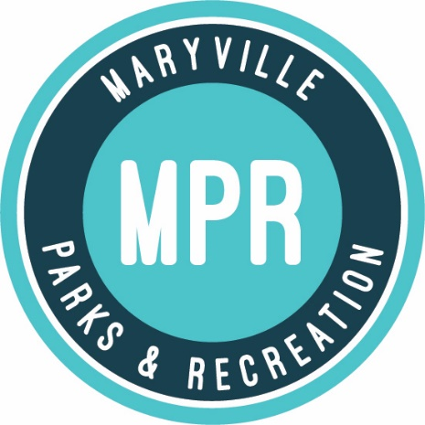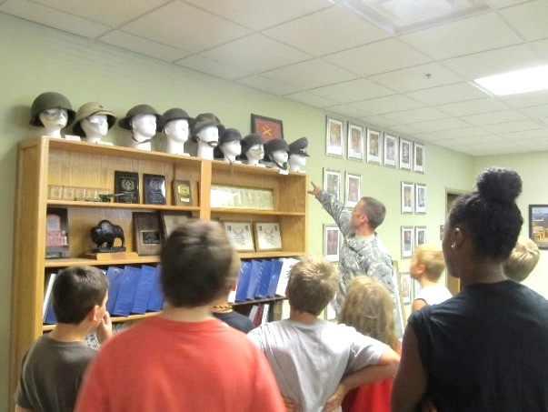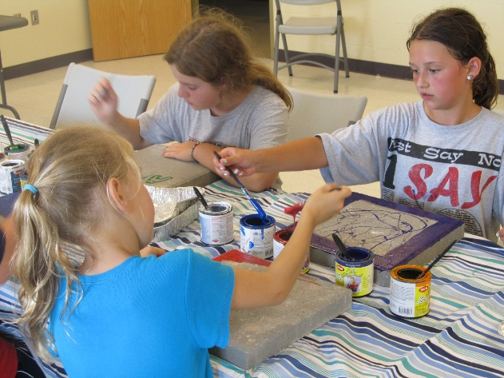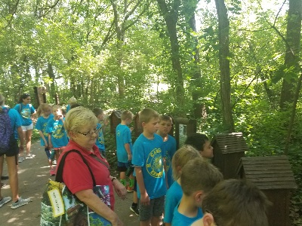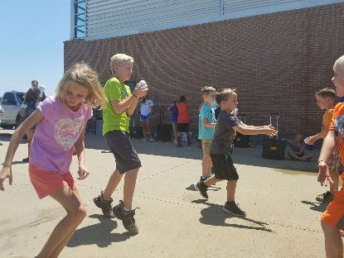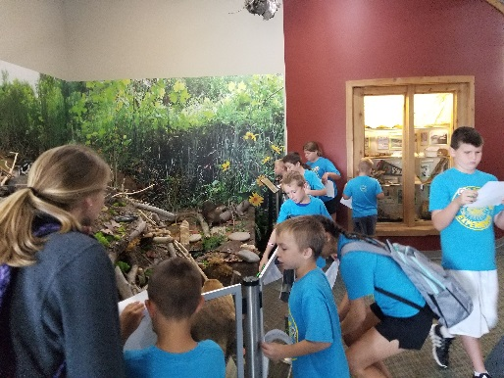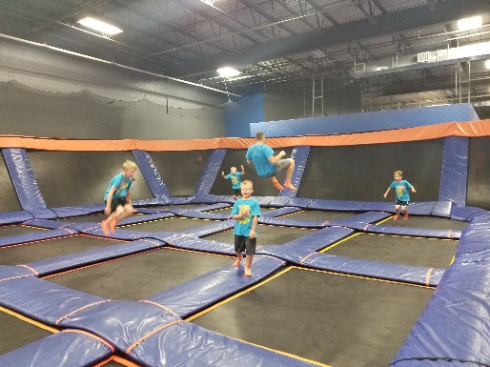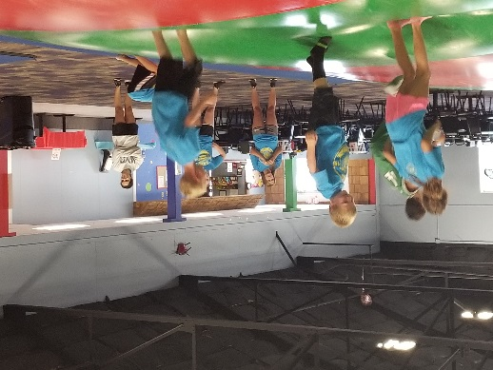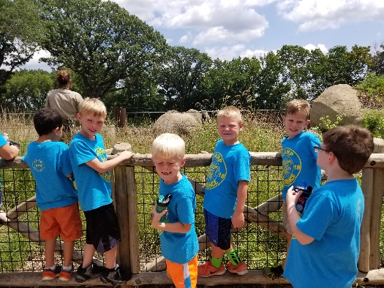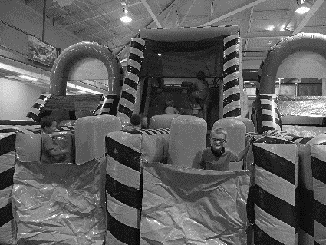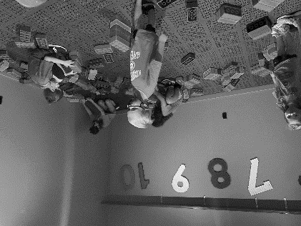 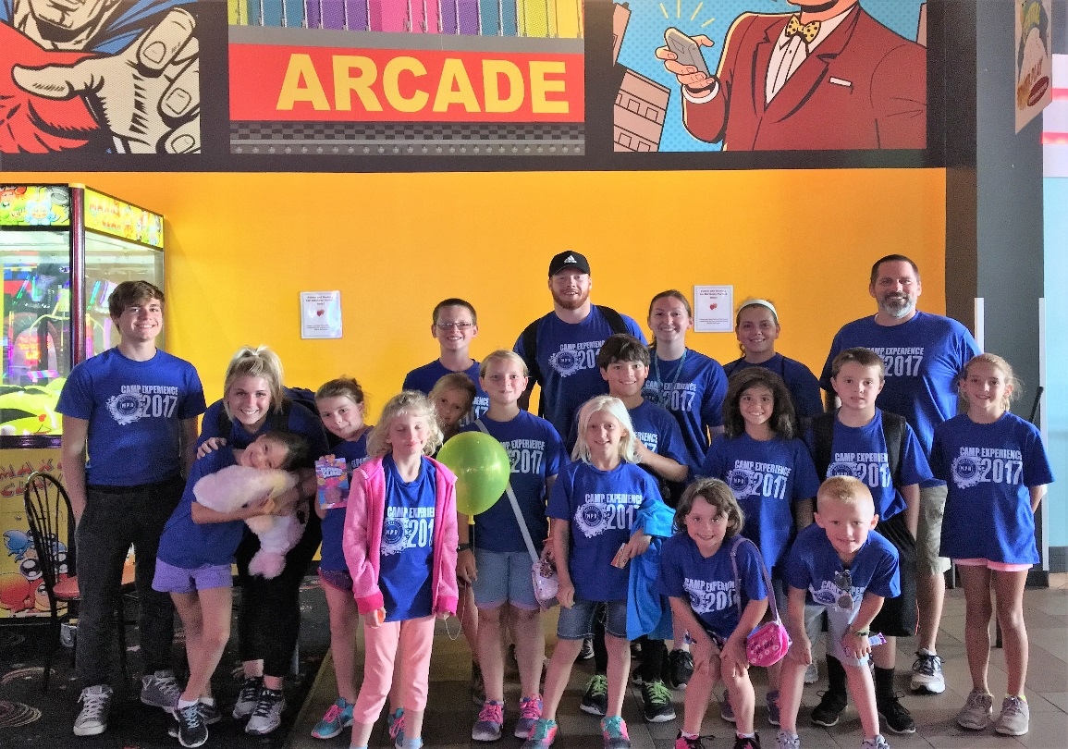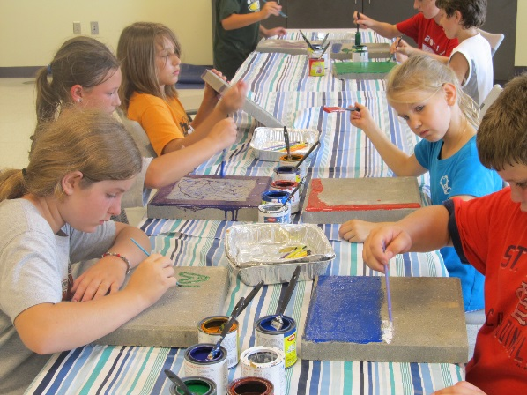

**Your text here**

Your text here

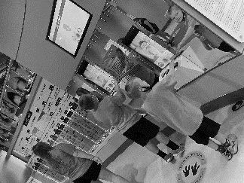

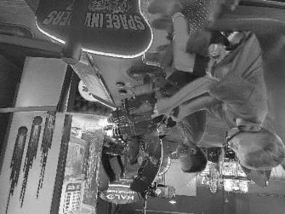 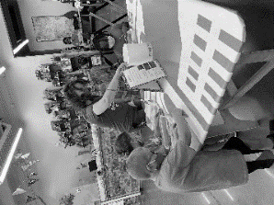

For more information on Camp Experience and other Maryville Parks & Recreation events and activities visit us at:

1407 N. Country Club Rd, Suite 200,

Maryville, MO 64468

Phone: 660.562.2923

Fax: 660.562.3829

maryvilleparks.org facebook.com/maryvilleparksrecreation

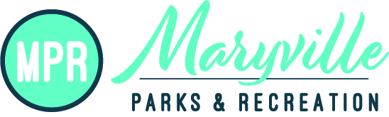

CAMP EXPERIENCE 2022

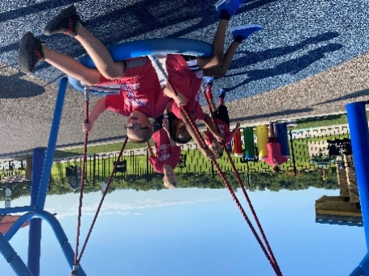 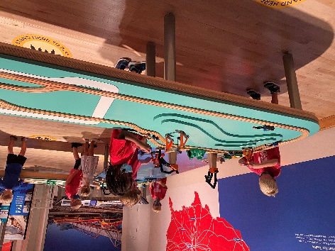

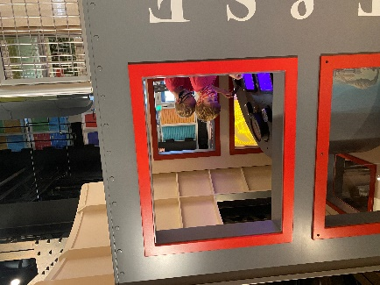 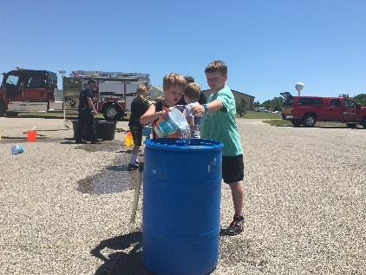

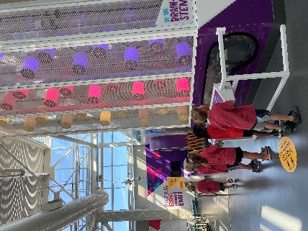 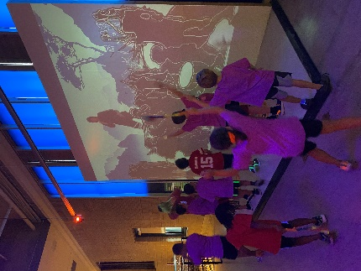 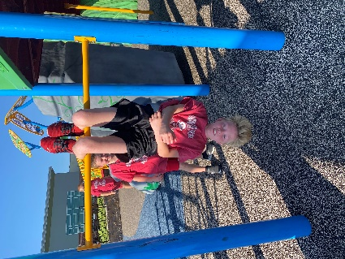

MAKE IT MONDAY * TALK ABOUT IT TUESDAY * WATER WEDNESDAY * TAKE A TRIP THURSDAY * FUN FRIDAY

CRAFTS, SNACKS, GAMES, SPEAKERS, EXPERIMENTS, BOOKS, PODCASTS, POOL, FIELDTRIPS, MOVIES AND SO MUCH MORE EVERY WEEK!

|  |  |  |  |  |  |  |
| --- | --- | --- | --- | --- | --- | --- |
|  |  | | | | | |
| PIRATE WEEK  JULY 5TH- 8TH | UNDER THE SEA WEEK  JULY 11-15TH | DINO WEEK  JULY 18TH-22ND |  | SPACE WEEK  JULY 25TH-29TH | ADVENTURE IS OUT THERE WEEK  AUGUST 1ST-5TH | MONSTERS WEEK  AUGUST 8TH-12TH |
| *Special Guest and Field trips are subject to change* | | | | | | |

**Camp Information**

Join MPR this summer as we offer a fun summer camp! This summer camp will be available for ages 5-12. Campers will enjoy participating in fun and exciting activities which include games, arts & crafts, swimming, fitness, team building, field trips, special guests, and more.

**Drop Off & Pick Up**

Campers may be dropped off as early as 7:00am and picked up no later than 6:00pm

**Lunch & Snack**

Campers will need to bring their own non-refrigerated lunch & water bottle daily. A snack in the afternoon will be provided.

**Other Tidbits**

**Campers will receive a Summer Fun Camp t-shirt that we ask campers to wear on Field Trips.** We will take campers to our Aquatic Center; campers will need to bring a swimsuit and towel with them. Every day we will spend some time outside so please send sunscreen with your child as well.

**Parent Information Night**

Thurs June 17th from 6pm - 7pm

Parents this is an opportunity for you to ask questions, meet the counselors, check out the facility, and have a little fun.

**Fees**

**WEEKLY RATE:**

$130 / $110-additional sibling(s)

**MULTI WEEK RATE:**

(register for 3 weeks of camp):

$120 / $100-additional sibling(s)

* **Cancellation Policy: Must notify by Wednesday of previous week if any cancellation**. **Late notice cancellation will be applied. This fee will be based on activities for that week.**

At time of registration, first and last week fees (if signing up for more than one week) must be paid in full for each child. When you sign up for multiple weeks, payment for the upcoming week must be paid in full by Friday at 6 pm of the previous week. Registration will be taken on a first-come basis. Camp space is limited to 40 campers per week. Campers will be placed in age appropriate groups.

For more information contact Bailey Fergison at 660-254-0312 or events@maryvilleparks.org.